9th lecture
Derivation of Kirchhoff’s laws from the steady state Maxwell’s equations
Kirchhoff’s two laws as they are known from our high school studies are the following two statements:
Kircchoff’s current (or node)law: The algebraic sum of all the currents at any node in a circuit equals zero.
Kircchoff’s voltage (or loop) law: The algebraic sum of all the voltages around any closed path in a circuit equals zero.
Kirchhoff’s laws - which have so many pracical applications - are not independent of Maxwell’s equations. In fact we can derive these laws from a particular form of Maxwell’s equations, which is valid in a steady state:

$$\begin{aligned}\text{rot} H =j (I) \\ \text{rot} E =0 (\text{II}) \\ \text{div} B=0 (\text{III}) \\ \text{div} D=ρ (\text{IV})\end{aligned}$$

For the derivation we need the steady state equations (I) and (II). Equation (I) can be regarded as a local form of the current law. This is because if take the divergence of both sides of Equation (I) we obtain that
which means that the field of the electric current density has no source. (Here we applied that the div(rotv)=0 for any vector field v, thus div(rotH)=0.) To obtain the usual global form of the current law we have to integrate the local form divj = 0. To this end let us regard the following Figure where the node of a circuit is surrounded by an imagined closed surface. The local form will be integrated to the volume surrounded by this closed suface. For the sake of simplicity we will regard a node where only three wires join:

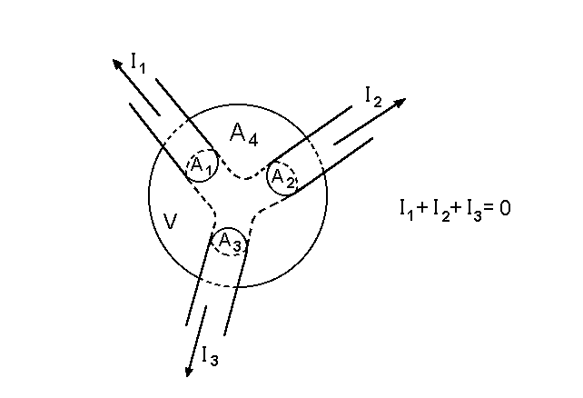
Schematic picture of a node. The node is surrounded by an imagined closed surface A. The surrounded volume is V. Surface A crosses all the three wires and the cross-sections are A₁, A₂, and A₃. The rest of the surface where the current density is 0, is denoted by A₄.

Let us regard now the following volume integral, which is tranformed to a surface inegral on the spot with the aid of the Gauss theorem:

$$\int_{V}{\text{div} j \text{dV}}=0, \int_{V}{\text{div} j} \text{dV}=\oint_{A}{j⋅dA}=\int_{A_{1}}{j⋅dA+\int_{A_{2}}{j⋅dA+\int_{A}{j⋅dA+\int_{A_{4}}{j⋅dA=0\text{.}}}}}$$

On the fourth surface the current density is zero thus the surface integral is zero there. The first, the second, and the third integral are the current flowing in the first, second and third wire respectively, that is

$$\int_{A_{1}}{j⋅dA=I_{1} , \int_{A_{2}}{j⋅dA=I_{2} , \int_{A_{3}}{j⋅dA=}}}I_{3} \text{.}$$

(Here we regarded the currents flowing out of the node as positive as in the case of a closed surface it is our convention that the outer normal of the surface is the positive direction) This way we obtained the usual global form of the current law:

$$I_{1}+I_{2}+I_{3}=0,$$

or in general, in the case of a node where n wires join:

$\sum_{k=1}^{n}{I_{k}=0\text{.}}$

Describing with words the above equation means that the algebrain sum of the currents flowing out of a node is zero. (In this case all currents flowing in are negative.) Alternatively (if we do not like negative currents) we can say that the sum of the currents flowing into a node is equal to the sum of the curents flowing out of a node.
Kirchhoff’s voltage law can be derived from Maxwell’s second equation as it can be written in steady state. If we want to apply this local form to a global loop of a circuit (a closed path of the circuit) then we have to integrate the local form to a surface which is surrounded by the loop. In the next step that surface integral should be transformed to a closed path integral with the aid of the Stokes theorem:

$$\int_{A}{\text{rot} E⋅dA=0 , \int_{A}{\text{rot} E⋅dA=}\oint_{G}{E⋅dr} , }\oint_{G}{E⋅dr}=0 \text{.}$$

That is the line integral of the electric field strength along a closed path G is zero. In other words the electric potential exists not only in electrostatics but in the case of direct currents as well. To obtain the usual form of the voltage law let us regard the following Figure:
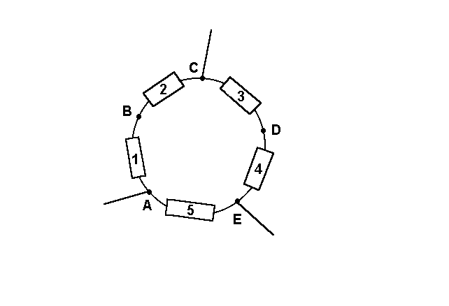
A loop in a steady state electric circuit. The boxes represent arbitrary elements (like battery, resistor or any nonlinear element). The lines represent wires without any resistance (ideal conductors) along of which the electric potential is constant.

Regarding the above closed path G with five elements the line integral for this loop can be written as:

$$\oint_{G}{E⋅dr=\int_{A}^{B}{E⋅dr+\int_{B}^{C}{E⋅dr+\int_{C}^{D}{E⋅dr+\int_{D}^{E}{E⋅dr+}}}}}\int_{E}^{A}{E⋅dr}=0 \text{.}$$

The five terms in the above integral are the five volage drops on the elements of the loop that is:

$$U_{1}+U_{2}+U_{3}+U_{4}+U_{5}=0,$$

which expression can be easily generalized for a loop with n elements:

$$\sum_{i=1}^{n}{U_{i}=0\text{.}}$$

In the actual applications of Kirchhoff’s laws, however, we usually make a distinction between the voltage drop on a battery (on a so called voltage source or active element of the circuit) and the volage drop on a linear or nonlinear resistor (a passive element of the circuit). In the next paragraph we will specify the various sources of the electric voltage.

Contact potential and thermoelectricity. Galvanic cells. Electromotive force or electromotance
In this chapter we discuss phenomena when the charge carriers are affected not only by electric forces but when so called „foreign” forces i.e. non electric or „charge separating” forces are also playing a role. Why do we need such forces? This is because without such forces no electric phenomena would be possible: the positive and negative charges would not separate but would stay together forever. If charge carriers e.g. electrons leave a material for another (e.g. when we rub the glass with a piece of leather and the glass becomes positively charged while the leather aquires a negative charge ) this happens with the help of foreing forces and this is against the electric forces which do not separate unite the oposite charges.
Let us see an experiment for the contact potential.

When a paraffine ball is removed from water the water gets positively and the paraffine ball negatively charged. This is because the surface of the paraffine is a very weak ion exchanger containing e.g. some carboxylic groups. When this carboxylic groups ionize the hydrogen ions can leave the neighborhood of the surface. This process stops, however, when the appearing electric field gets strong enough to withhold the remaining hydrogen ions. The order of magnitude of this voltage is 1 V. This small voltage in itself would not be enough to cause a measurable deflection of the electrometer. But when we remove the paraffine ball from the water the capacity of the water-paraffine condenser decreses orders of magnitude and the resulting increase in the voltage cause a measurable deflection.
In the case of insulators the origin of the charge sepatating forces is usually not clear. In many cases even the identity of the carge carriers (ions or electrons or holes) is not known. The theory is well known in the case of metals and semiconductors, however.

Contact potential between metals

The chemical potential of an electron in a metal depends on the chemical quality of the element. If the chemical potential in metal A is higher while in metal B is lower then electrons will flow from A to B until the so called electrochemical potential of the electrons are the same in the two metals. (The electrochemical potential is the sum of the chemical potential and the electric potential of one mole electron.) Thus in equilibrium
μ_{A} -F⋅ϕ_{A} = μ_{B} - F⋅ϕ_{B}
where μ_{A} and μ_{B} is the chemical potential energy of one electron in the metal A and B respectively, -F is the charge of one mole electron (-96500 As), and -F⋅ϕ_{A} and -F⋅ϕ_{B} are the electric potential energy of one mole electron in the metal A and B. Thus the contact potential can be expressed as

ϕ_{A} - ϕ_{B} = (μ_{A} - μ_{B})/F

Let us regard now a real experiment, where a metal plate made of Zn for examle contacts another one made of Cu. Let the Zn plate be connected with the potential sensing point of an electroscope, while the Cu plate be connected to the case of the electroscope. (See the Figure). As we know copper is more electronegative than zinc thus electrons move from zinc to copper making the Cu plate negative and the Zn plate positive.

Figure
The appearing potential difference is the contact potential. If the two plates are separated from each other the capacitance of the parallel plate capacitor decreases and the potential increases which is indicated by the electroscope. While the contact potential cannot be measured directly with a volmeter it can be measured based on the principle illustrated by the above experiment.
_____________________________________________________________________
A method to measure contact potentials
The contact potential difference can be measured e.g. by the vibrating capacitor method. Let us construct a parallel plate electric capacitor the plates of which be made of two different metals A and B. When these plates are connected via a resistor R, the voltage between the plates of the capacitor will be just the contact potential V_{contact}. In the case when a voltage source ε is also inserted in series with R then the voltage between the plates will be
U_{C} = V_{contact} + ε.
At the same time the voltage on the resistor will be zero as long as the plates are static. If we start to move the plates of the capacitor back and forth, however, an alternating curent will flow through the resistor, which can be measured. This is because the charge Q on the capacitor is chaning
Q = C⋅ U_{C}
following the change in the capacity:
I = dQ/dt = U_{C}⋅dC/dt
This alternating current is zero however if
V_{contact} + ε = 0.
Thus by chnging ε we can compensate the contact potential and the negative of this compensating voltage is the contact potential
V_{contact} = - ε .
______________________________________________________________

Contact (or Volta) potential. The official IUPAC definition
The electric potential difference between one point in the vacuum close to
the surface of M1 and another point in the vacuum close to the surface of
M2, where M1 and M2 are two uncharged metals brought into contact.

The metals can be arranged into a Volta or contact potential series similarly to the electrochemical series:
(+) Al, Zn, Pb, Sn, Sb, Bi, Fe, Cu, Ag, Au, C (-)
This series follows the order of the increasing electronegativiy roughly but not perfectly (According to Linus Pauling electronegativity is "The power of an atom in a molecule to attract electrons to itself." ) The deviation is due to the fact that the two different metals are not forming a molecule but two homogeneous metallic crystal lattice are in contact and try to attract electrons to themselves.
Thermoelectricity
For the contact potential series Volta discovered an important law: under isothermal conditions the contact potential between two metals is the same independently whether the two are connected directly or some other metals are connected between.
Thus if we connect any metallic conductors in a loop we cannot observe a current as long as all the metals and contacts are at the same temperature. The situation is different, however, if the contact points are at different temperatures. In this case we can observe the thermoelectric Seebeck effect. (Thermocouple. See the laboratory exercise) The reciprocal effect – when an electric current flowing through a thermocouple one joint is heated while the other is cooled. – is the so called Peltier effect.

Galvanic cells

Ohm’s law in the presnce of foreign forces. Electromotive force or electromotance. The active and passive elements of an electric circuit

In an electric circuit two different elemnts can be found. One one element we can measure a voltage only if a current is flowing through that element. This can be a linear element like a resistor or a nonlinear one like e diode. These are the so called passive elements. We cannot obtain an electric current in a circuit when it contains passive elements only.
There are some other elements, called as active ones, where a voltage can be measured even in the absence of an electric current. How can we explain that? If there were only electric forces acting on the charge carriers of an active element then a current should appear. In electrostatics we often mentioned that if we have an electric field in a conductor (and a galvanic cell is a good conductor) then electric current should appear. We have to assume some foreign forces acting on the charge carriers in the galvanic cell, which counterbalance the electric force acting also on the charge carrier within the cell, thus the resulting force is zero:

F_{Electric} + F_{Foreign} = 0.

Here F_{Electric} is the electric and F_{Foreign} is the foreign force acting on Q_{CC} (the charge of the electric carrier). Let us divide the above equation with Q_{CC} , which is the charge of the charge carrier in the active element. Then we can write that

E + E^{f} = 0,

where
E = F_{Electric}/ Q_{CC} and E^{i} = F_{Foreign}/ Q_{CC}

This way we can write
$$E+E^{i}=0\text{.}$$

Let us assume that we have a simple unloaded galvanic cell. Let us note its two terminals with A and B. Then let us calculate the following integral:

$$\int_{A}^{B}{( E+E^{i} )⋅dr=0 , \int_{A}^{B}{E⋅dr+\int_{A}^{B}{E^{i}⋅dr=0, U_{1}}}}+ε_{1}=0 ,$$

where
$$U_{1}=\int_{A}^{B}{E⋅dr , \text{valamint} ε_{1}}=\int_{A}^{B}{E^{i}⋅dr} \text{.}$$

The subscript 1 indicates that this galvanic cell can be the first element of a circuit. Thus if we have an unloaded galvanic cell we can write the following equation:

$$U_{\text{telep}}+e_{\text{telep}}=0,\text{vagy}e_{\text{telep}}\text{=-}U_{\text{telep}}\text{.}$$

When we write Kirchhoff’s voltage law usually we regard ideal galvanic cells ( cells without an inner ohmic resistance) where the voltage between its terminals is independent of the current flowing through the cell. Now we can write Kirchhoff’s voltage law of the previous chapter with applying two different voltages: active and passive ones:

$$\sum_{i=1}^{N}{U_{i}}=\sum_{j=1}^{m}{U_{j,\text{aktív}}+}\sum_{k=1}^{n}{U_{k,\text{passzív}}=0 , \text{vagy} \sum_{k=1}^{n}{U_{k,\text{passzív}}=\sum_{j=1}^{m}{ε_{j}}} \text{.}}$$

(Here we applied that in the case of ideal cells .) The usual form of Kirchhoff’s voltage law can be obtained if we assume that the passive elements are simple resistors satisfying Ohm’s law, that is

$$U_{k,\text{passzív}}=R_{k}⋅I_{k} \text{.}$$

Thus we obtain the most frequently applied form of the voltage law:

$$\sum_{k=1}^{n}{R_{k}}I_{k}=\sum_{j=1}^{m}{ε_{j}} \text{.}$$

